Worksheet 2.3

Student Name: Sahil Kaundal UID: 21BCS8197

Branch: CSE (Lateral Entry) Section/Group:20BCS-807_B Semester: 4th Date of Performance: 29/03/2022

Subject Name: SE Lab Subject Code: 20CSP-255

Q1.

1. Aim/Overview of the practical:

Design a Sequence and collaboration diagram of an Online Exam System

1. Task to be done/ Objective:



* Sequence diagrams are used to represent message flow from one object to another object.
* Sequence diagrams are used to explore any real application or a system.
* The collaboration diagrams are better suited for depicting simpler interactions of the smaller number of objects.
* Collaboration diagrams are used to understand the object architecture of a system rather than message flow.

1. Requirement Analysis:

Software Requirement:

* Smart Draw
* Google Chrome

Hardware Requirement:

* Computer
* Windows 10
* Power Supply

1. Sequence Diagram:

A Sequence Diagram is an interaction diagram that details about the operation that is carried out. The sequence diagram captures the interaction between the objects in the context of collaboration. Sequence diagrams are time focused and they show the order of the interaction visually by using the vertical axis of the diagram to represent time.

1. Collaboration Diagram:

**Collaboration Diagram** represents the interaction of the objects to perform the behaviour of a particular use case or a part of use case. The designers use the Sequence diagram and Collaboration Diagrams to define and clarify the roles of the objects that perform a particular flow of events of a use case.

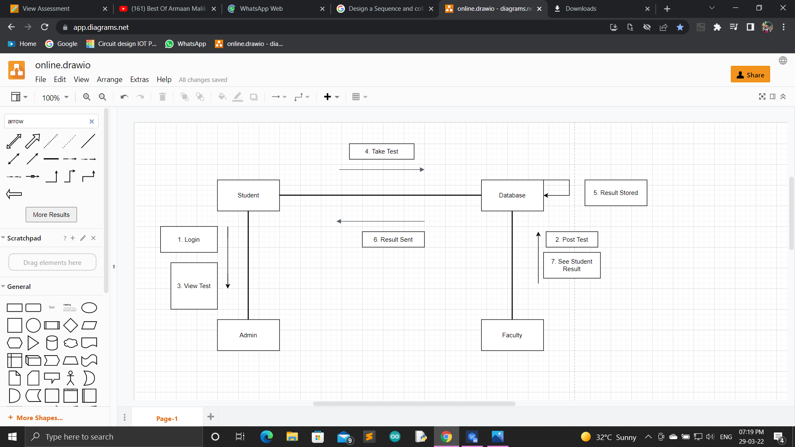

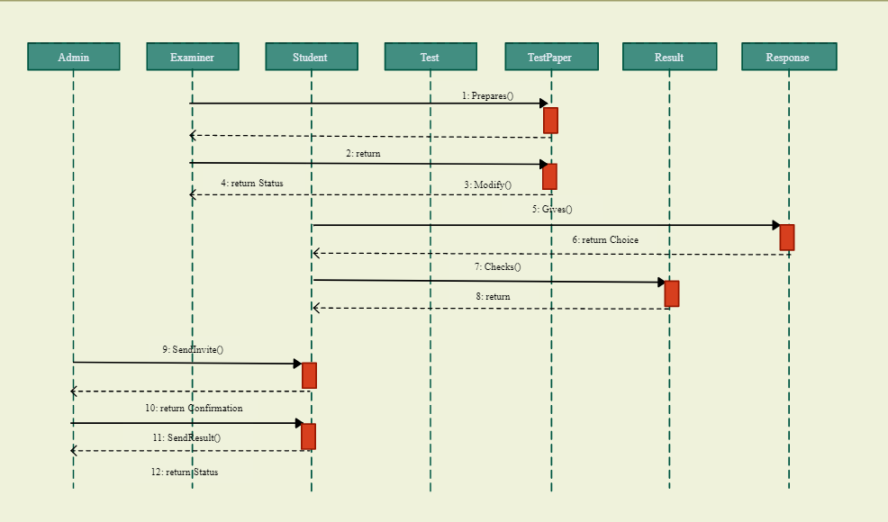

Q2.

1. Aim/Overview of the practical:

Design a Sequence and collaboration diagram of School Management System

1. Task to be done/ Objective:



* Sequence diagrams are used to represent message flow from one object to another object.
* Sequence diagrams are used to explore any real application or a system.
* The collaboration diagrams are better suited for depicting simpler interactions of the smaller number of objects.
* Collaboration diagrams are used to understand the object architecture of a system rather than message flow.

1. Requirement Analysis:

Software Requirement:

* Smart Draw
* Google Chrome

Hardware Requirement:

* Computer
* Windows 10
* Power Supply

1. Sequence Diagram:

A Sequence Diagram is an interaction diagram that details about the operation that is carried out. The sequence diagram captures the interaction between the objects in the context of collaboration. Sequence diagrams are time focused and they show the order of the interaction visually by using the vertical axis of the diagram to represent time.

1. Collaboration Diagram:

**Collaboration Diagram** represents the interaction of the objects to perform the behaviour of a particular use case or a part of use case. The designers use the Sequence diagram and Collaboration Diagrams to define and clarify the roles of the objects that perform a particular flow of events of a use case.

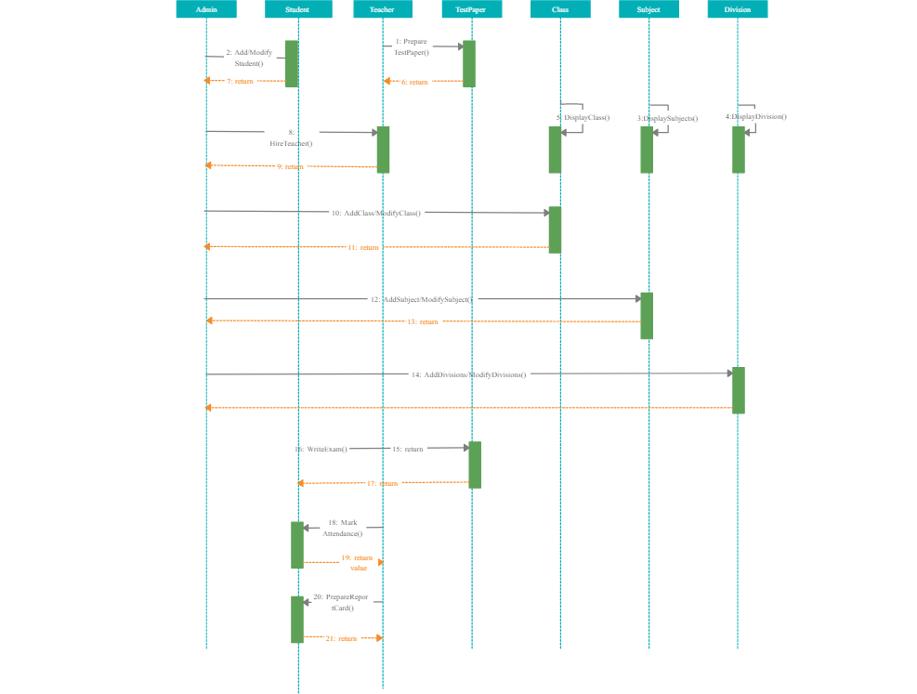

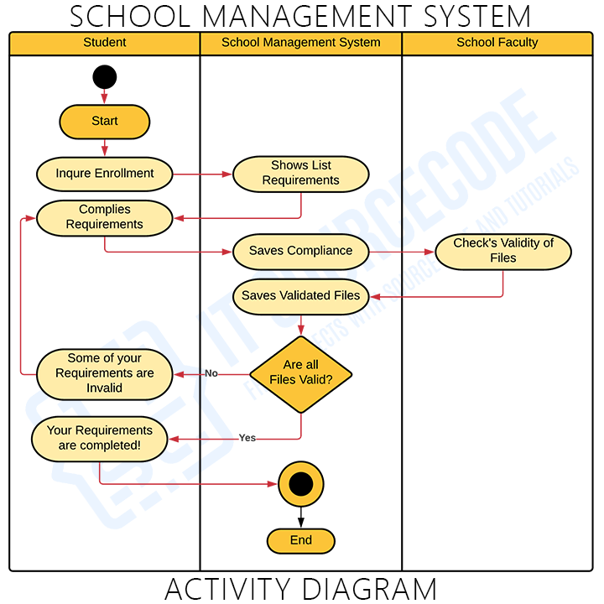

1. Result/Output/Writing Summary:

I have successfully done this practical.

Learning outcomes (What I have learnt):

1. Learned about Sequence Diagram.
2. Learned about Collaboration Diagram.

Evaluation Grid (To be created as per the SOP and Assessment guidelines by the faculty):



|  |  |  |  |
| --- | --- | --- | --- |
| Sr. No. | Parameters | Marks Obtained | Maximum Marks |
| 1. |  |  |  |
| 2. |  |  |  |
| 3. |  |  |  |
|  |  |  |  |